Step:1 First, draw the Topology diagram 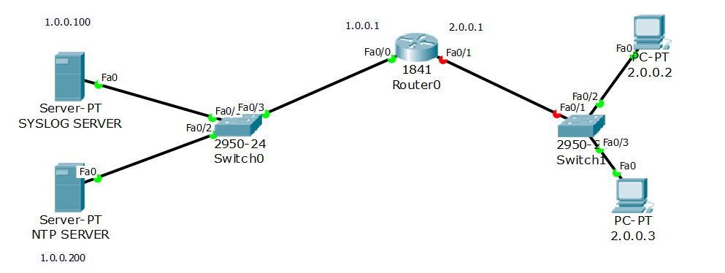

Step:2 assign IP address and gateway IP to all the devices, including servers.

Step 3: Visit the SYSLOG Server and enable it from services.

Step 4:Now Go to the router and Tell the Router about the Syslog machine.

R1#config t

Enter configuration commands, one per line. End with CNTL/Z.

R1(config)#logging host 1.0.0.100

R1(config)#logging trap debugging

Step 5: Syslog Server Troubleshooting

VISIT ROUTER AND DISABLE ANY PORT TO SEE THE LOG ON SYSLOG SERVER.

R1>enable

R1#config t

Enter configuration commands, one per line. End with CNTL/Z.

R1(config)#int fa0/1

R1(config-if)#shut

R1(config-if)#

%LINK-5-CHANGED: Interface FastEthernet0/1, changed state to administratively down

%LINEPROTO-5-UPDOWN: Line protocol on Interface FastEthernet0/1, changed state to down

R1(config-if)#

check Syslog server for any Log:

